**IDX G9 MATH H STUDY GUIDE ISSUE 2**

**By Samuel**

1. **Isosceles triangles**

Definition:

-leg: the congruent sides of an isosceles triangle

-base: the third side

-vertex angle: the two congruent sides form the vertex angle

-base angle: the other two angles are the base angles.

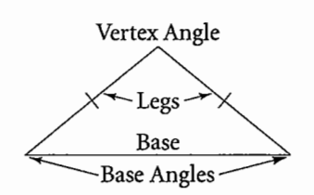

Theorem:

-Isosceles triangle theorem: If two sides of a triangle are congruent, then the angles opposite those sides are congruent.

-Converse of Isosceles Triangle theorem: If two angles of a triangle are congruent, then the sides opposite the angles are congruent.

-The bisector of the vertex angle of an isosceles triangle is the

perpendicular bisector of the base.

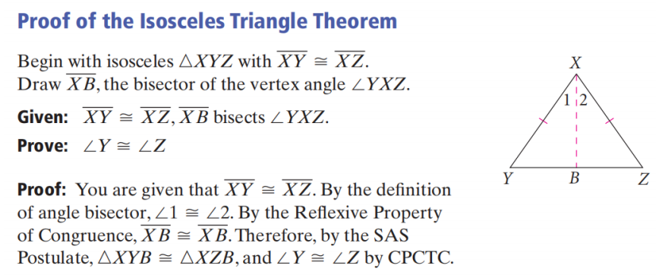

1. **Equilateral Triangles**

-If a triangle is equilateral, then the triangle is equiangular.

-If a triangle is equiangular, then the triangles equilateral.

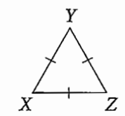 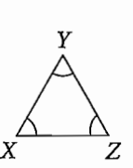

1. **Inequalities in Triangles**

-The measure of an exterior angle of a triangle is greater than the measure of each of its remote interior angles.

m1>m2 and m3

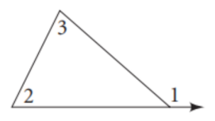

-Theorem 5-10: If two sides of a triangle are not congruent, then the larger angle lies opposite the longer side.（大边对大角）

-Theorem 5-11: If two angles of a triangle are not congruent,then the longer side lies opposite he larger angle.（大角对大边）

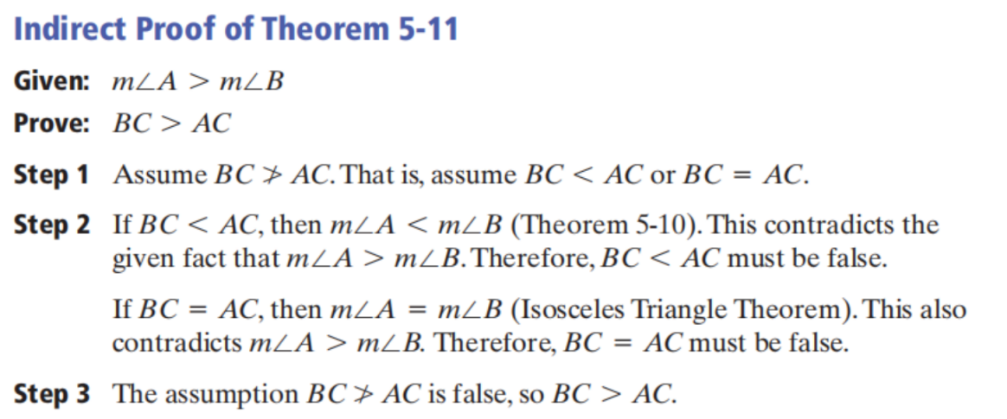

-Theorem 5-12: The sum of the lengths of any two sides of a triangleis greater than the length of the third side.

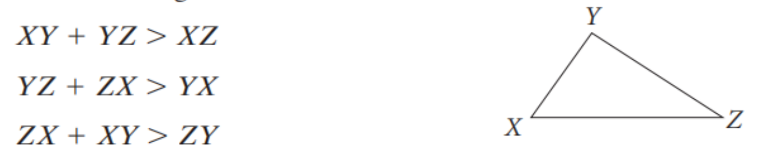

**4.Bisectors in Triangles**

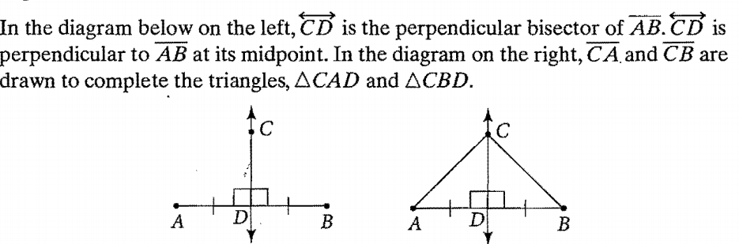

Perpendicular bisector of a line is a line that perpendicular to the midpoint of the line

Theorem:

-Perpendicular bisector theorem: If a point is on the perpendicular bisector of a segment, then it is equidistant from the endpoints of the segment.

-Converse of perpendicular bisector theorem: If a point is equidistant from the endpoints of a segment, then it is on the perpendicular bisector of the segment.

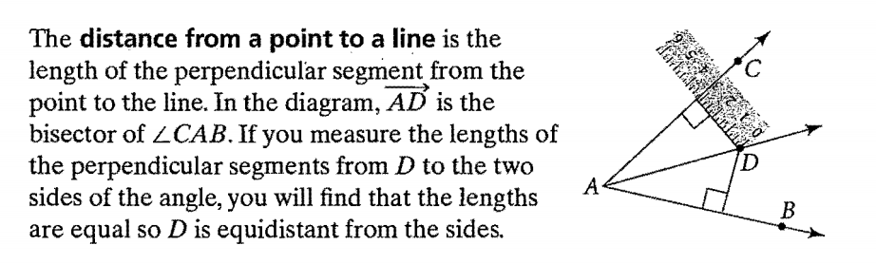

-Angle Bisector theorem: If a point is on the bisector of an angle, then the point is equidistant from the sides of the angle.

-Converse of angle bisector theorem: If a point in the interior of an angle is equidistant from the sides of the angle, then the point is on the angle bisector.

**5.Concurrent Lines, Medians, and Altitudes**

Definition:

-When three or more lines intersect in one point, they are concurrent.

-The point at . which they intersect is the point of concurrency.

-For any triangle, four different sets of lines are concurrent.

-The point of concurrency of the perpendicular bisectors of a triangle

is called the circumcenter of the triangle .

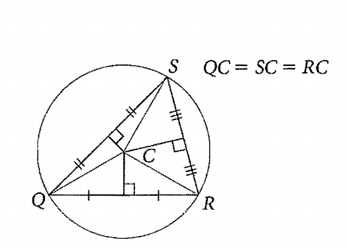

-;:;, .>t-.!I;""'#>~>3!~""'"

'"< --- -The point of concurrency of the angle bisectors of a triangle is called the incenter of the triangle.

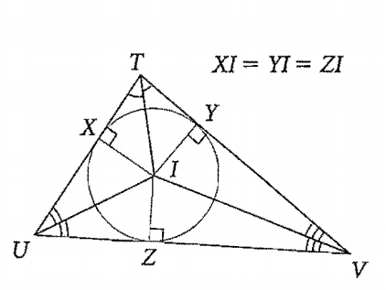

-A median of a triangle is a segment whose endpoints are a vertex and the midpoint of the opposite side.

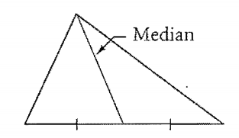

-An altitude of a triangle is the perpendicular segment from a vertex to the line containing the opposite side. Unlike angle bisectors and medians, an altitude of a triangle can be a side of a triangle or it may lie outside the triangle.

-The lines containing the altitudes of a triangle are concurrent at the

orthocenter of the triangle.

Theorem:

-Theorem 5-6: The perpendicular bisectors of the sides of a triangle are concurrent at a point equidistant from the vertices.

-Theorem 5-7: The bisectors of the angles of a triangle are concurrent at a point equidistant from the sides.

-Theorem 5-8: The medians of a triangle are concurrent at a point that is two thirds the distance from each vertex to the midpoint of the opposite side.

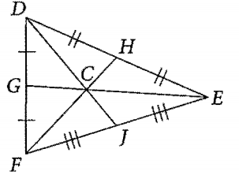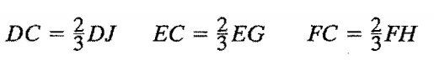

-Theorem 5-9: The lines that contain the altitudes of a triangle are concurrent.

_l '

"' II'"

V